**Make a responsive team members page with cards using flex**

Hello everyone, in this blog I will show you how to create a members page with cards using **display: flex.**

So, here is the preview of what I am talking about.

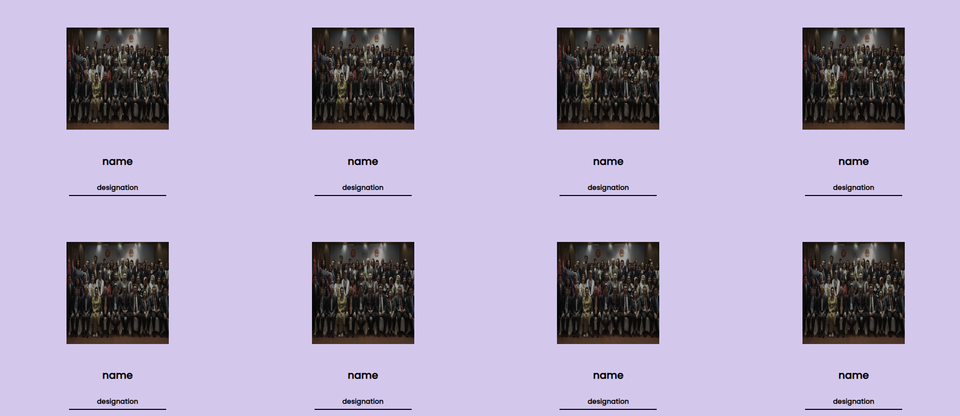

So, we are going to make this page fully responsive which will adjust itself according to the width of the screen.

It will look like this –

On desktop

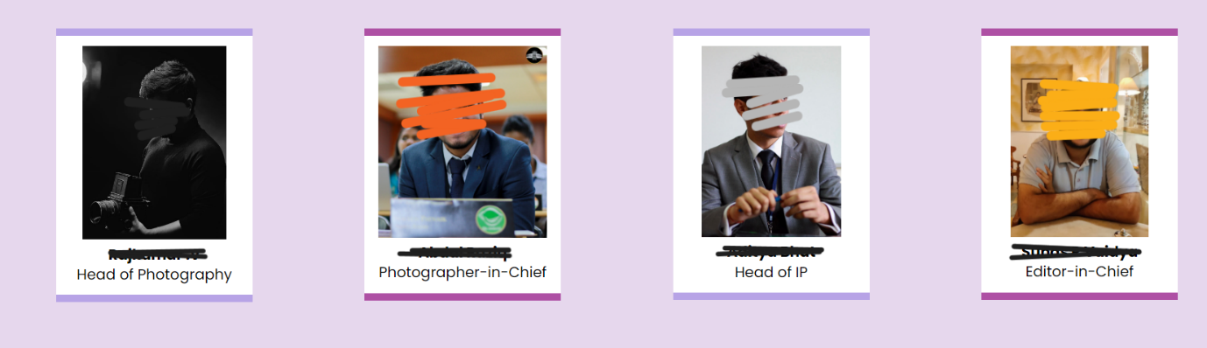

On Mobile

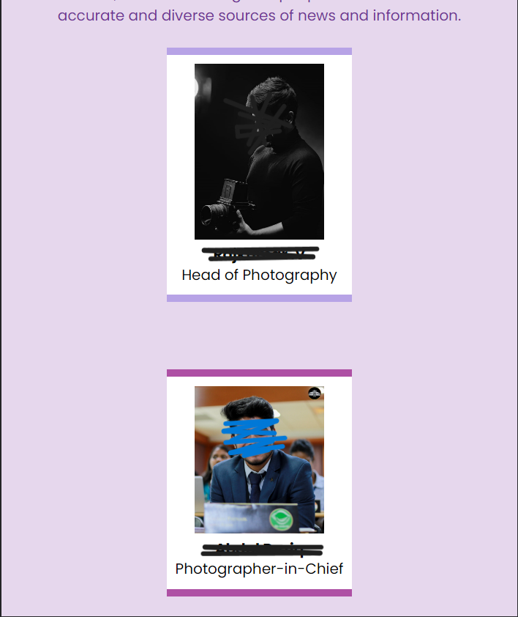

So, to start with, we will start with the basic html template and the we will add divs according to the following pattern:

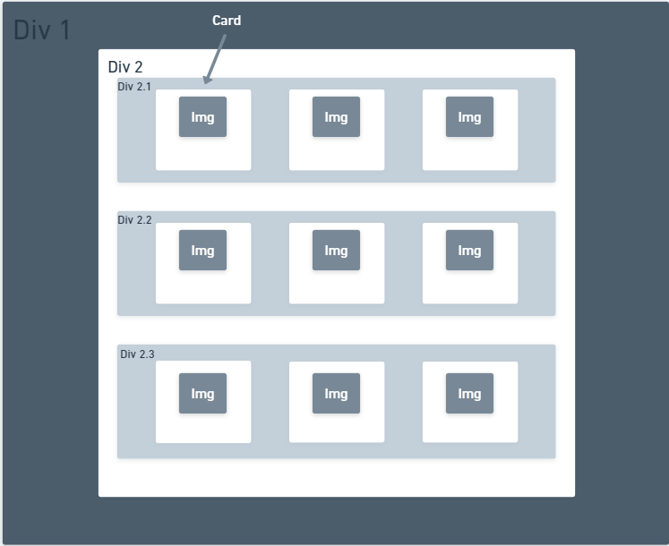

The **Div 1** will be the outermost div which will the basic div for the cards section.

**Div 2** is used to provide margins and padding from top-bottom and side.

The divs **2.1, 2.2, and 2.3** are the divs which will be holding the cards. Each div will be containing 3 cards in this example.

Now, these are the basic structure and now we will create the card. For that we will be defining another div which let us call as ‘card 1’. This will contain all the information which you need in a card. For example, Image, Name, Designation.

You can refer the following code for the above image.

<div class="div1"> <!--Main Section-->

        <div class="div2"> <!--Sub Section-->

            <div class="div2-1"> <!--Card Line 1-->

                <div class="card1"> <!--Card-->

                    <img src="" alt="">

                    <h4>Name</h4>

                    <p>designation</p>

                </div>

                <div class="card2"><!--Card-->

                    <img src="" alt="">

                    <h4>Name</h4>

                    <p>designation</p>

                </div>

                <div class="card3"><!--Card-->

                    <img src="" alt="">

                    <h4>Name</h4>

                    <p>designation</p>

                </div>

            </div>

            <div class="div2-2"><!--Card Line 2-->

                <div class="card1"><!--Card-->

                    <img src="" alt="">

                    <h4>Name</h4>

                    <p>designation</p>

                </div>

                <div class="card2"><!--Card-->

                    <img src="" alt="">

                    <h4>Name</h4>

                    <p>designation</p>

                </div>

                <div class="card3"><!--Card-->

                    <img src="" alt="">

                    <h4>Name</h4>

                    <p>designation</p>

                </div>

            </div>

            <div class="div2-3"><!--Card Line 3-->

                <div class="card1"><!--Card-->

                    <img src="" alt="">

                    <h4>Name</h4>

                    <p>designation</p>

                </div>

                <div class="card2"><!--Card-->

                    <img src="" alt="">

                    <h4>Name</h4>

                    <p>designation</p>

                </div>

                <div class="card3"><!--Card-->

                    <img src="" alt="">

                    <h4>Name</h4>

                    <p>designation</p>

                </div>

            </div>

        </div>

    </div>

Now, we will style it.

First make padding and margin of body to 0. Then we will arrange the card lines using display flex. Now, we will apply display flex on div2, then we will apply justify-content to centre. To align the text inside the card, we can apply text-align to centre. Now, by default the flex-direction is on the row. But for the better understanding we will apply flex-direction to row.

* {

    padding: 0;

    margin: 0;

}

.div1{

    background-color: aqua;

}

.div2{

    display: flex;

    justify-content: center;

    text-align: center;

    flex-direction: row;

    background-color: aquamarine;

    margin: 15% 10%;

    gap:10%;

}

Here I have given the gap of 10% between the cards. I have also added background-color to show the divs. The margin is added to align the div into center.

Before it was looking like this –

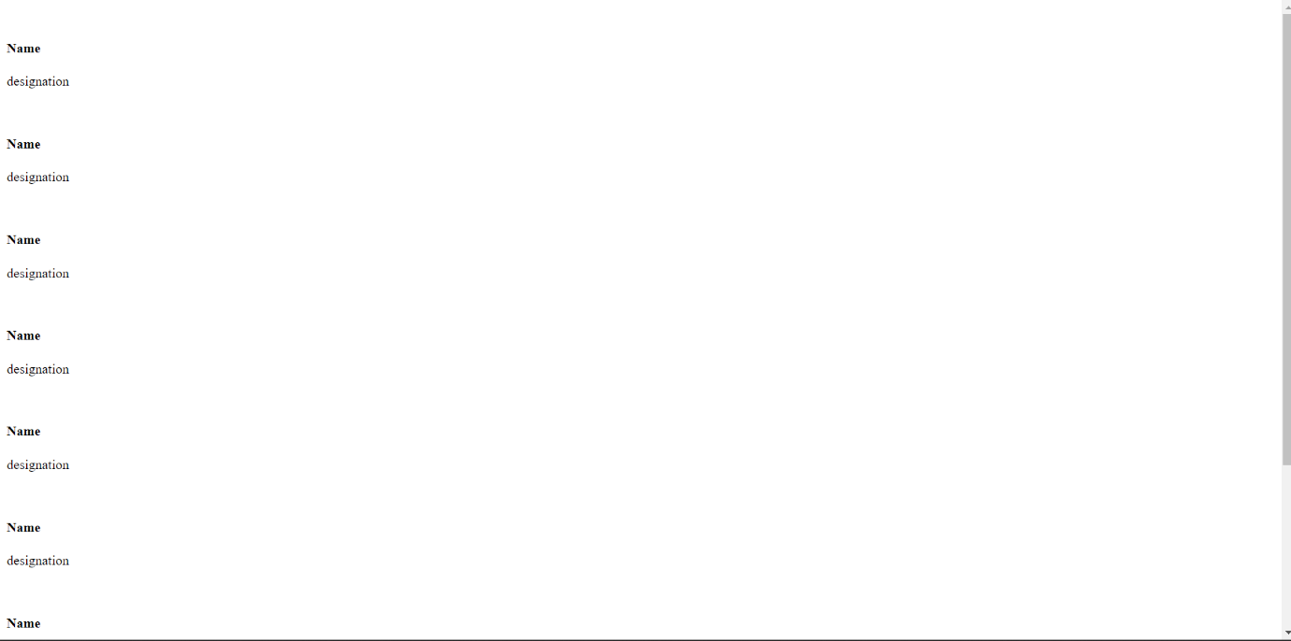

Now it looks like this –

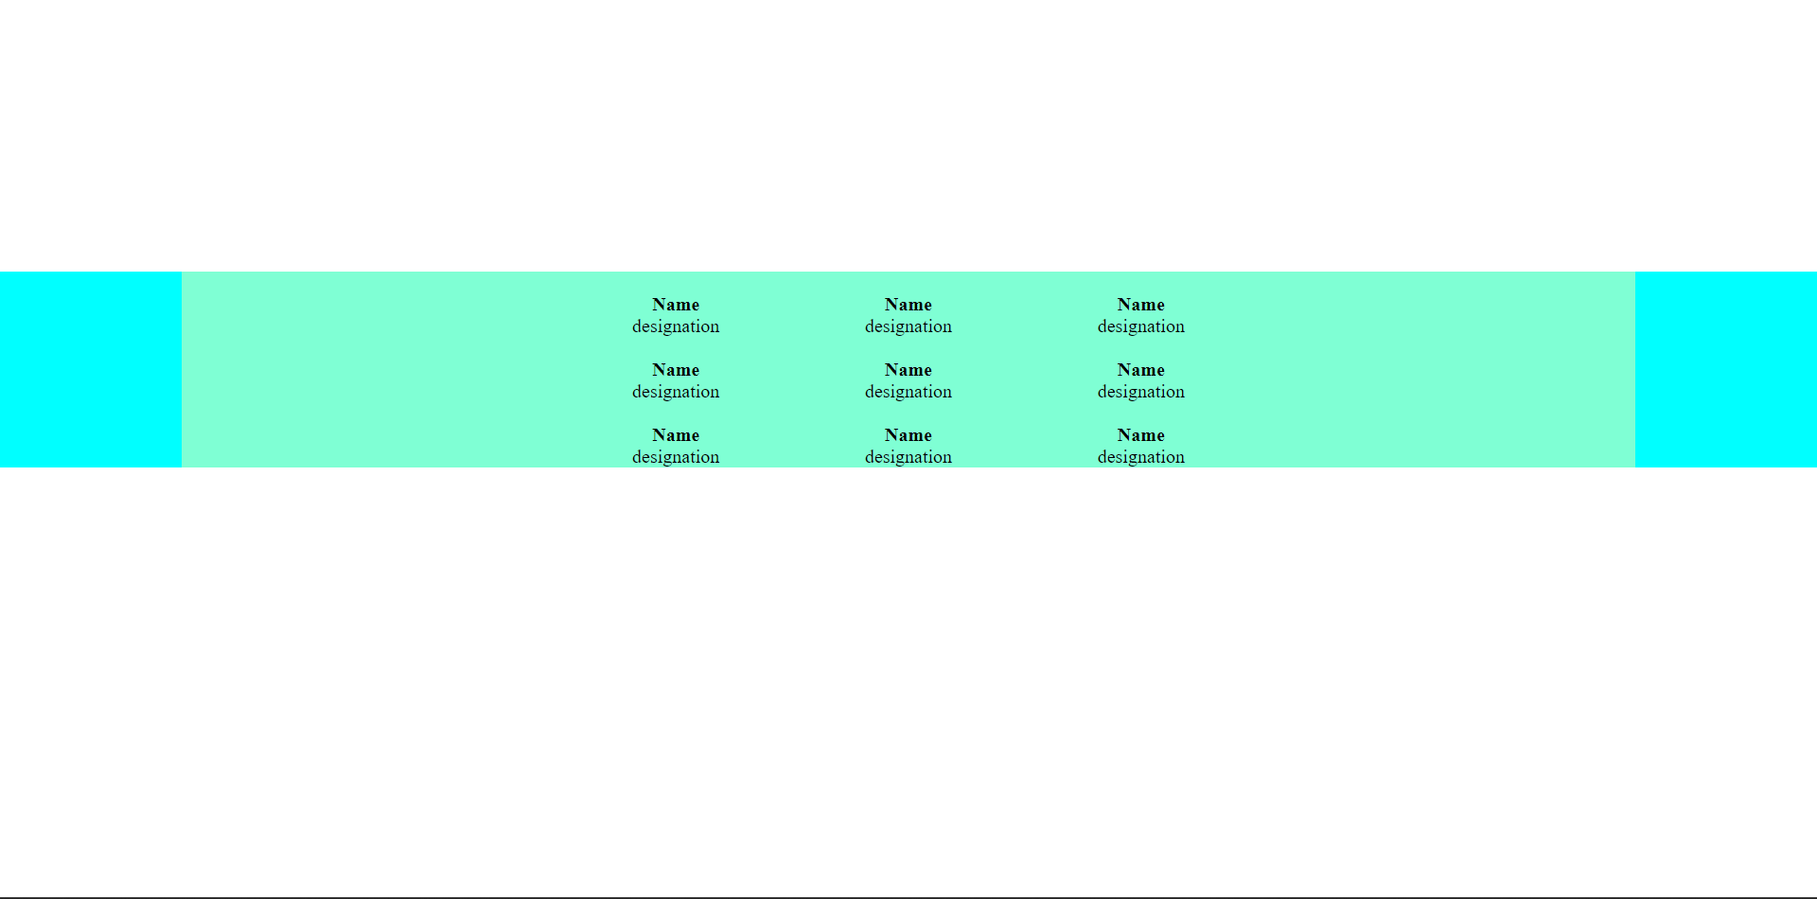

So, this are the basic structuring for desktop. It will be responsive for a lot of width as we have used % for margin which is an relative unit.

Now but when you see it in the mobile form, it will not look good!.

You can see it by right clicking on the webpage and clicking on inspect element and then by arranging the width.

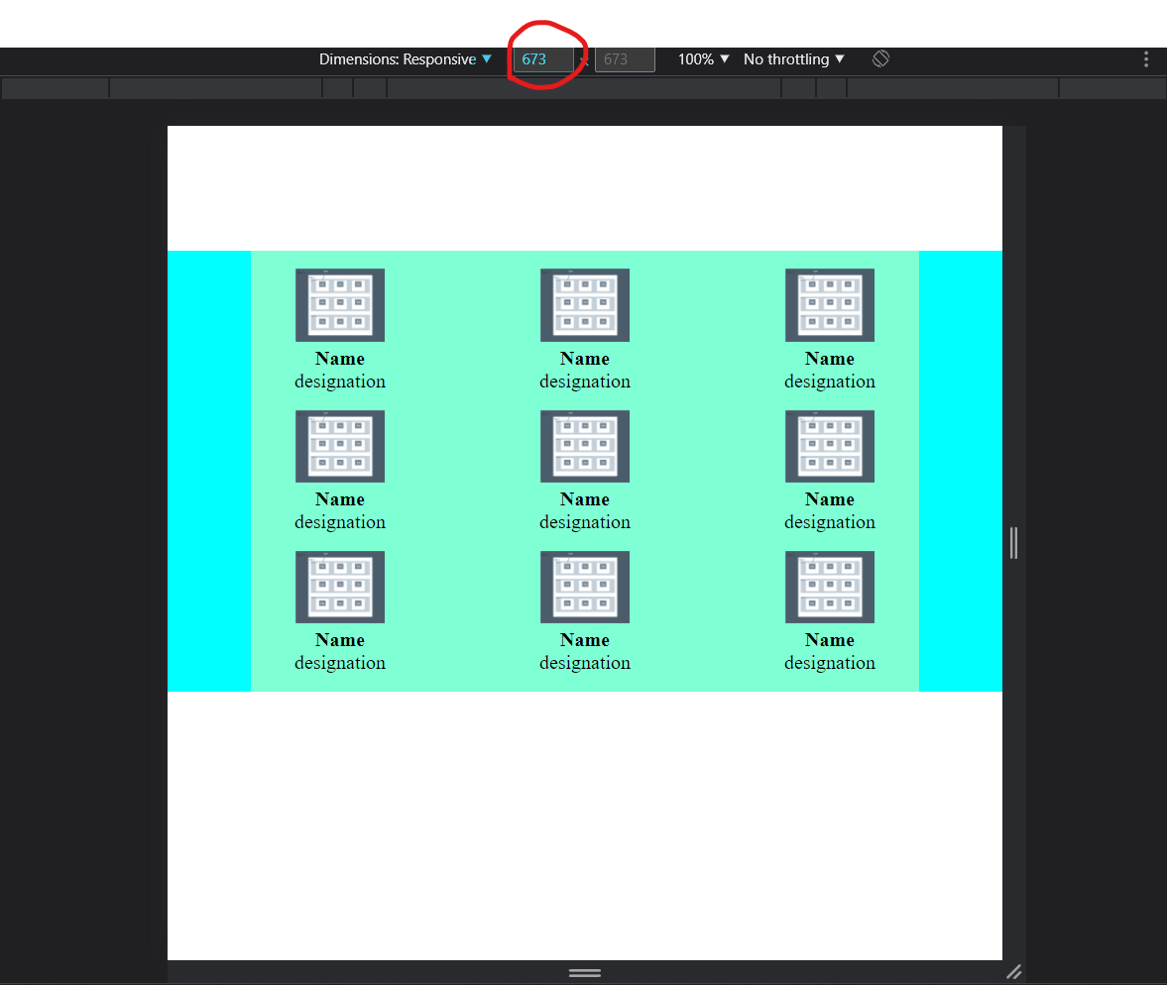

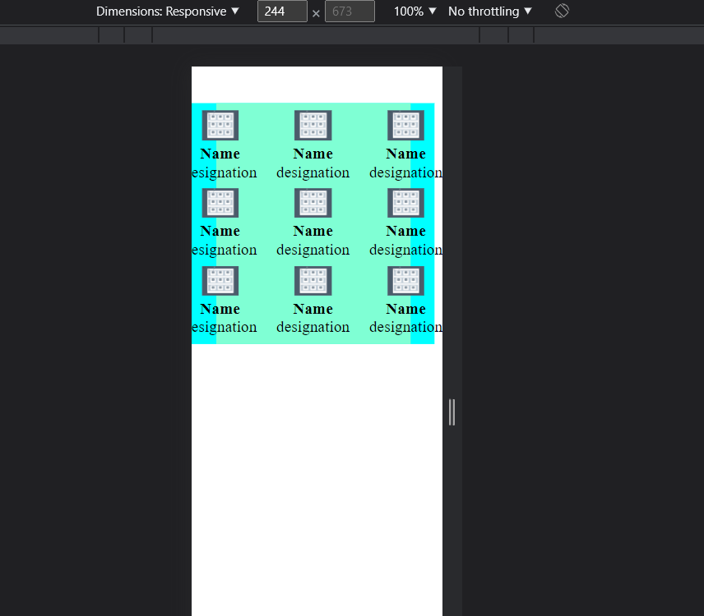

Here, it looks good till the width 673px but below that it doesn’t look good. Now I want to change the css such that it will looks good on the screens which this small width.

For that, we will use **media queries**. Media queries is a technique in CSS 3 which allows the content to change according to different criterions such as max-width. In out project also, we are going to use max-width in the media queries and we will set it to 673px. Then, in that media query, we will change the flex-direction of div2 to column which will show all the cards in the column instead of row.